A1125-ME-Ephesus-Artemis-1400 BCE

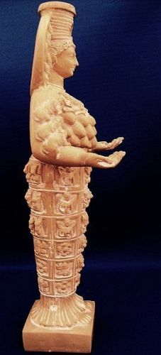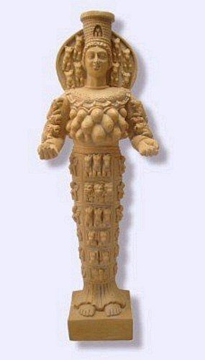

**Case no.: 4**

**Accession Number: A1125**

**Formal Label: Artemis of Ephesis-1400 BCE**

**Display Description:**

**In Ephesus Atremis was venerated as wild nature in an open-air tree sanctuary, suggesting that the earliest statures to her were made from a tree trunk of** *Quercetum frainetto-cerris* Rud **and sculpted into a pillar figure, which was maintained by local sculptors.**

The city of Ephesus was built in the 10th century BCE on the site of the former Arzawan capitalby Attic and Ionian Greek colonists. During the Classical Greek era (5th and 4th centuries BCE) it was one of the twelve cities of the Ionian League. The city flourished after it came under the control of the Roman Republic in 129 BCE.

The city was famed for the nearby Temple of Artemis (completed around 550 BCE), one of the “Seven Wonders of the Ancient World (Ring, Trudy and Salkin, Robert. 1995. "Ephesus". International Dictionary of Historic Places: Southern Europe. London: Fitzroy Dearborn, p. 217)

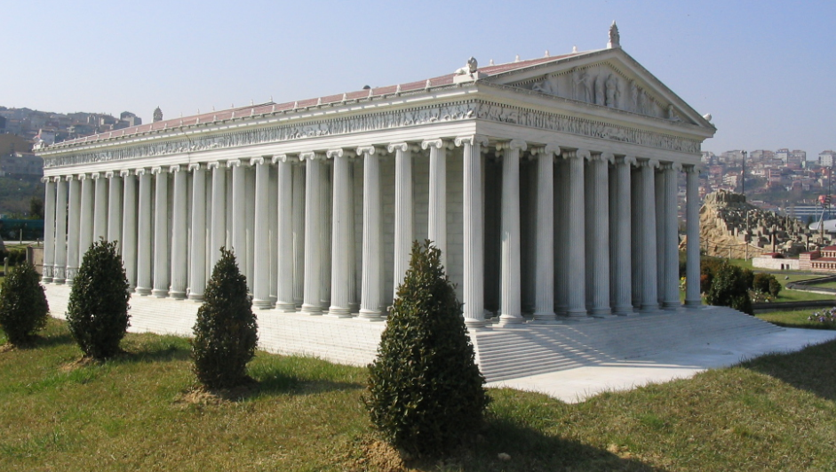

A probable replica of the Temple of Artemis of Ephesus in Turkey. Note the probable use of the wood from the *Quercetum frainetto-cerris* Rud. or Turkish oak for the Ionic columns, which would literally have replicated the forest of trees where Artemis once had her outdoor shrines. From https://upload.wikimedia.org/wikipedia/commons/1/1d/Miniaturk_009.jpg

The worship of Artemis (*Potnia Aswiya*, the cult of vegetation and fertility) was gradually developed to resemble its Greek counterpart *Potnia Theron*, the Mother of Animals. The final blow to the worship of Artemis of Ephesus came when her temple that had been built in the 7th century BCE and had been touted as one of the “Seven Wonders of the World” by Alexander the Great after his triumph at the [Battle of Granicus](https://en.wikipedia.org/wiki/Battle_of_Granicus) in 334 BCE. After Alexander's death in 323 BCE, Ephesus in 290 BCE came under the rule of one of Alexander's generals, Lysimachus. The river [Cayster](https://en.wikipedia.org/wiki/Cayster) (*Κάϋστρος*) silted up the old harbor. Malaria developed in the Anopheles mosquitos in the marshes, which caused many deaths. Lysimachus forced the people to move from the ancient city surrounding the temple of Artemis to the present site two km (1.2 miles) away, and as a last resort the king flooded the old city by blocking the sewers (Strabo. 1923–1932. Geography, volumes 1–7. Cambridge: Loeb Classical Library, Harvard University Press. pp. 14.1.21.)

was burned to the ground by raiding Goths in 356 BCE.

This sculpture is based on a 7th century replica, which was one of the most popular. She wears a polos crown representing Ephesus’ city walls and its entry gate in the middle. Behind the crown is a nimbus or halo of the Sun disk with 4 sphinx protomes (προτομή) representing the upper part of sphinxes on both sides of her head. Originally this nimbus may have been a decorated shawl which the naked goddess could have covered herself. The eight sphinx protomes indicate that this is a replica of the sculpture in the Naples Museum, and they and the Sun disk suggest her connection to the Egyptian pantheon. Her braided hair is worn up. However, in a Basel Museum copy the hair is worn loose in strands over her shoulders. Her hands are turned upwards which simultaneously suggest giving and receiving, which may have held wool (a symbol of giving) that drooped to the ground. In each upraised hand sat falcons, her auditory predators. Her breast is covered by a crescent-shaped lunula from which hang acorns of the Turkish oak, *Quercetum frainetto-cerris* Rud. This reinforces the upright structure of her stature which was sculpted from these straight-trunked trees and of the visual aspect of the tall, straight oak tree glades that once harbored her shrines.

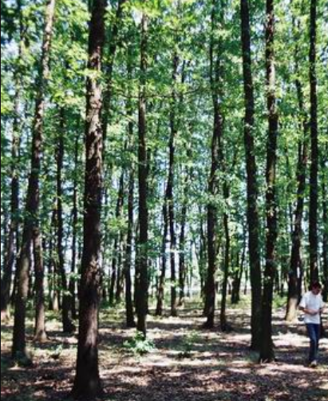 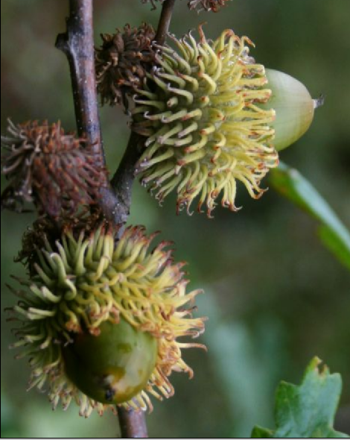

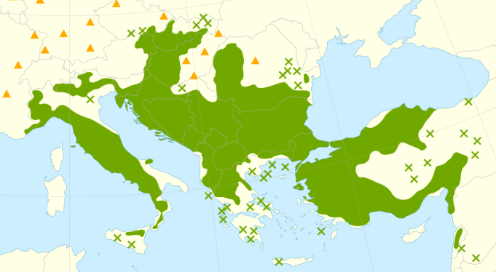

Fig. Glade of *Quercetum frainetto-cerris* Rud. (from *By Stefanst at English Wikipedia, CC BY 2.5,* [*https://commons.wikimedia.org/w/index.php?curid=5985839I*](https://commons.wikimedia.org/w/index.php?curid=5985839I)*).*

Fig. *Quercetum frainetto-cerris* Rud. Acorns showing structure of the acorn shell that is repeated in the crescent-shaped lunula on her breast (after <https://upload.wikimedia.org/wikipedia/commons/b/b1/Quercus_cerris_5.jpg>).

Fig. Distribution map of *Quercetum frainetto-cerris* Rud from Caudullo, G., Welk, E., San-Miguel-Ayanz, J., 2017. Chorological maps for the main European woody species. Data in Brief 12, 662-666. DOI: [10.1016/j.dib.2017.05.007](https://doi.org/10.1016/j.dib.2017.05.007). See also for distribution of *Quercetum frainetto-cerris* Rud in Turkey from Browicz, K., Zieliński, J. 1982, *Chorology of trees and shrubs in south-west Asia and adjacent regions*, vol. 1. Warsaw, Poznań: Polish Scientific Publishers.

**LC Classification:**  DF221.E5

**Date or Time Horizon:** ca 232 BCE

**Geographical Area:** Ephesus

**Map, GPS coordinates:**  37.941111,27.341944; [37°56′28″N 27°20′31″E](https://tools.wmflabs.org/geohack/geohack.php?pagename=Ephesus&params=37_56_28_N_27_20_31_E_type:landmark)

**Cultural Affiliation:** Greek

**Medium:** *Quercetum frainetto-cerris* Rud

**Dimensions:**

**Weight:**

**Condition: replica of Naples Museum copy**

**Provenance:**

**Discussion:**

**References:**